Festivals from Brăila
Some festivals that take place in our city every year are The days of Braila, International festival of light music “George Grigoriu”, National festival of folk “ Chira Chiralina” and National festival “ Mihai Eminescu”.
Each festival takes place in a different part of the year.
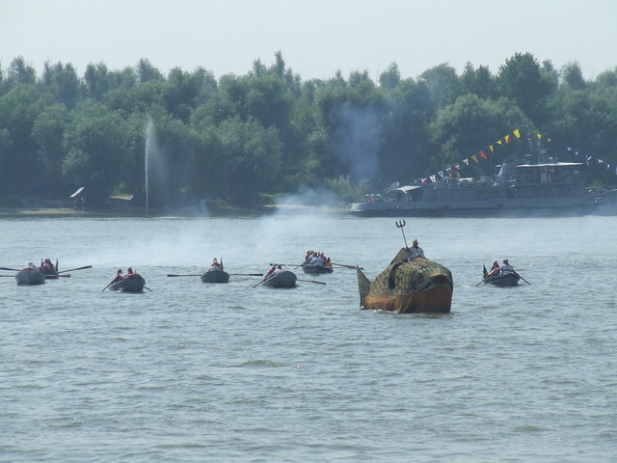
The days of Braila
We celebrate them between 13.08 and 16.08. The mayor with the support of the city hall organizes concerts, shows and games with prizes in order to make all the people have fun and feel good. This year “Iris” came on our stage and in the end, we had a firework show.

International festival of light music “George Grigoriu”
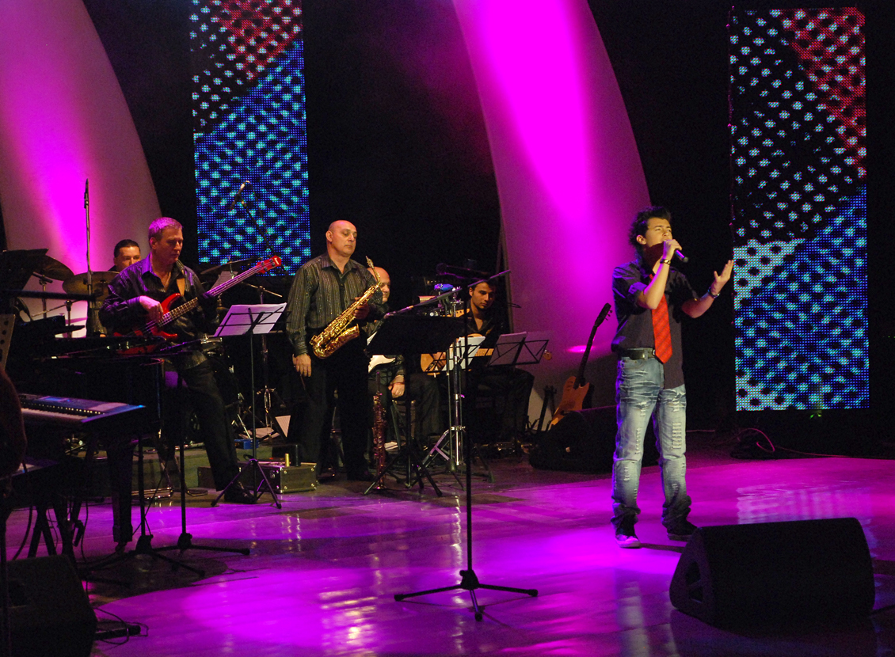
This festival takes place between 22.05 and 24.05. It’s being organized by the County Council, the County Centre for Conservation and Promoting Traditional Culture, the Union of Composers and Musicologists of Romania and Romanian Society of Broadcasting.
The 20 contestants, with ages between 16 years and 29 years, both Romanian and foreign, compete in front of a jury for the prizes and the fame of being the best. The winner takes home the trophy and 2500 Euros.

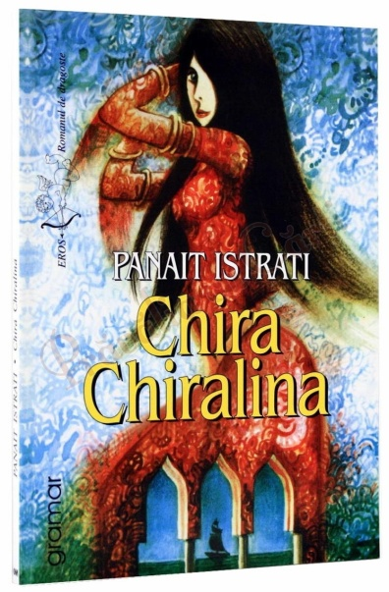
National festival of folk “ Chira Chiralina”
The organizers of this festival are the County Council and the Centre of Creation Braila with the honour president Nicu Alifantis – son of Braila. The period is 7.11 and 9.11 and Braila’s Youth House is where it takes place. The goal of this festival is to discover and promote new talents in creation and interpretation of folk music, to keep alive the tradition of this genre in Braila.

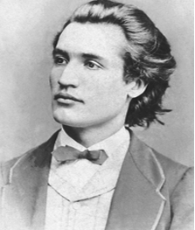

National festival “ Mihai Eminescu”
This event is being organized by the International Foundation for Culture, Science and Civic Morale “Mihai Eminescu”. Although it is a national festival, it has international participation.
The two stages for this event have different time periods. The first one is between 15-18 January and the second one is between 1-15 June. Those two stages highlight the talent for theatre, music, reciting and composing.
Also, the National festival “Mihai Eminescu” is cultural, an educational model for all the students.

Made by: Zodilă Emil, X A

