Fifth meeting of the “Everybody fits in” project
France- La Ciotat

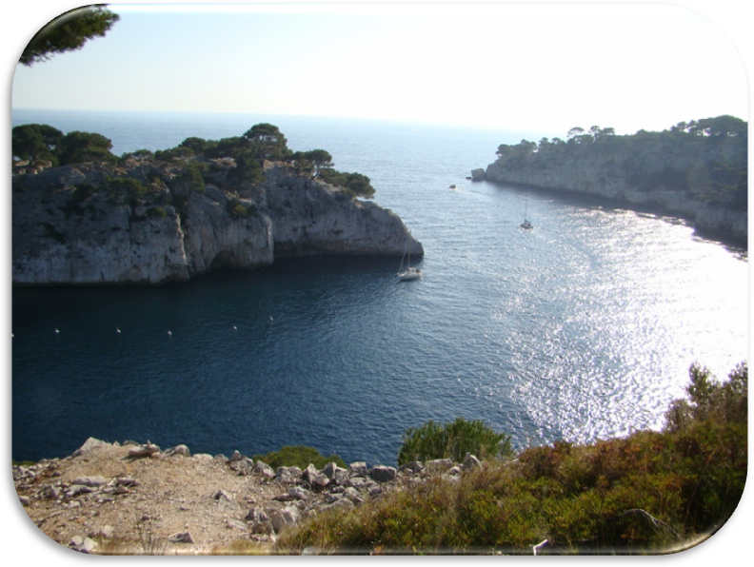
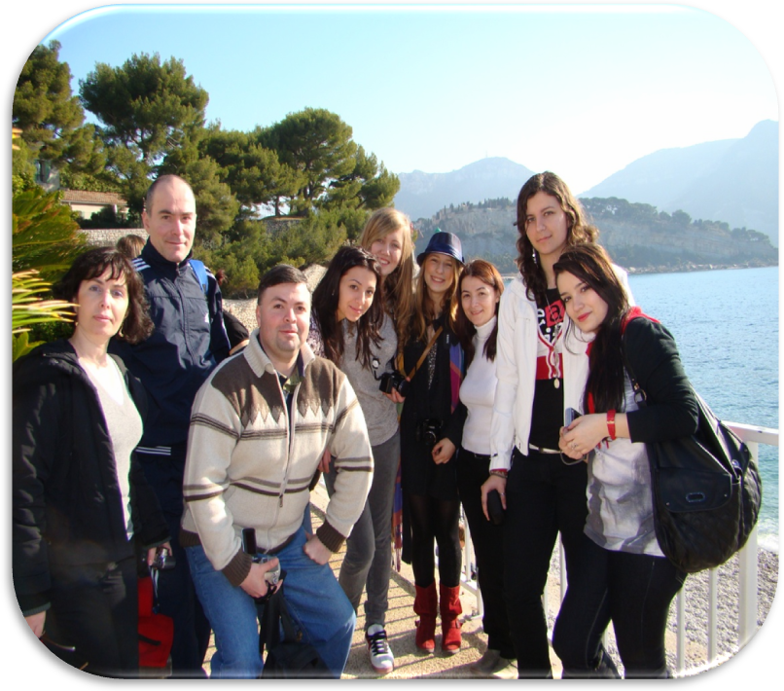
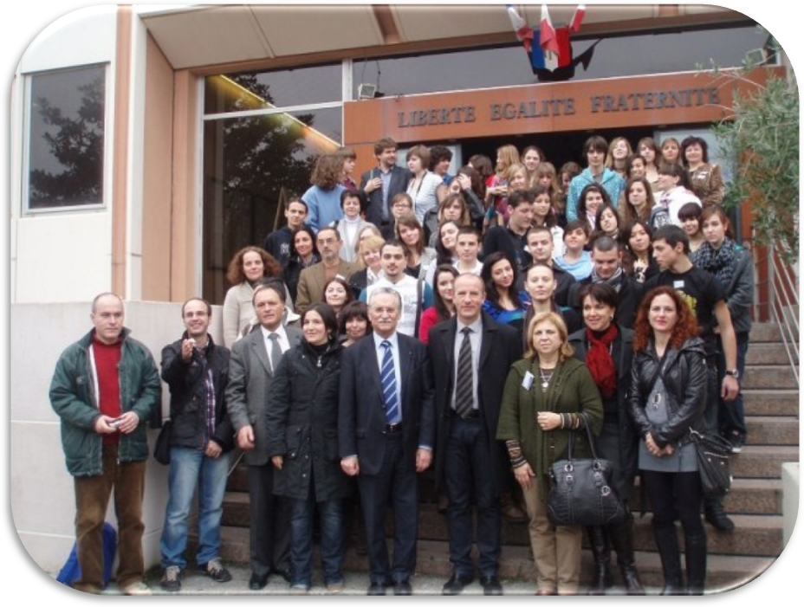

In our life we have traveled to many beautiful places. Most of them in our mind are a blur, but one place we have never forgotten. And this place it is called La Ciotat. Paris has the Eiffel Tower, San Francisco has the Golden Gate Bridge, Sydney has the Opera House. However, what is La Ciotat famous for? La Ciotat has a long history and various cultures. We were absolutely impressed by the great variety of places we have visited such as: Voie du Belvedere, Place Emile Zola, the Calanques, the cathedral Notre Dame de la Garde, the village Le Castellet, the local harbour where large boats visit its waters and say hello to the green trees that surround it. When the wind blows strongly, you can see the fish trying to reach its bank; nevertheless, they can't do it, because the waters reclaim them like a treasure. We felt that the city La Ciotat was alive and attractive.
Another important aspect that pleased us is related to the people from France. The french people always spoke quietly in order not to bother other people, so I think we all should learn from this kind of behaviour. We learned about french kindness, when someone asked for something they always smiled trying to be nice to foreigners.
Apart from all the marvelous places we visited, the atmosphere between us was magnificient. We laughed, we shared our thoughts, experiences and we became friends for life.
La Ciotat is the greatest place to ever visit.

Made by student Ana Maria Malaia, XIIth grade, Romanian team

